Trevor Bekolay, 6796723, umbekol0
Assignment 3, Question 5

A multistage interconnection network (MIN) is a dynamic topology network in which messages go through multiple stages of routing elements before reaching its destination port.

Benes Networks
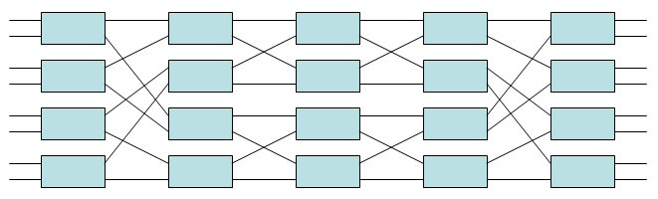
Figure 1 - An 8 input, 8 output Benes network
(Source: http://en.wikipedia.org/wiki/Clos_network)

To route from a source address i to a destination address j, we first must realize that a Benes network is just a simple multi-stage network folded in on itself; as such, we can follow the same routing algorithm as the simple multi-stage network from stage log₂(N) onwards (where N is the number of inputs/outputs). So, faced with any amount of inputs and outputs (<=8), we can use the first log₂(N)-1 stages to place each input in a state where it can reach its output without conflicts.

The advantage of the extra log₂(N)-1 stages is that we can route any permutation of inputs to outputs without conflicts; that is, the Benes network is a non-blocking network. The disadvantages are that it takes time to compute the paths for a given input and output, and we must have a global list of the messages in the network so that we can do the computations to route without blocking; we have to do these computations offline. Further, there are more stages to go through in the MIN, resulting in higher latency.

